|  |  |  |  |  |  |
| --- | --- | --- | --- | --- | --- |
| Date | 1-Dec-22 | | | Tester Name | Natalia Kokhman |
| Environment | Penfax - Test | | | Login used |  |
| Operating System | Windows | Version: | Update: | | |
| Software Used | Edge | Version: | Update: | | |
| Select Software | Version: | Update: | | |
| Release version | 22.4.1 | | | | |
| Title | E5 Employment Terminations | | | | |
| Test Type | Regression | | | | |
| Test Scenario | E5.04 Terminate someone with 1 employer and re-enrol them with a different employer on the same date | | | | |
|  |  | | | | |
| Expected Results | 1 of the employments should be ended with the End Reason Termination.  Member Status should remain Active.  Termination Option Letter should be available in Penfax and Member PLANet. | | | | |
| Pass/Fail | Fail | | | JIRA# | N/A |

Describe your steps with screenshots:

1. Bring up active member.

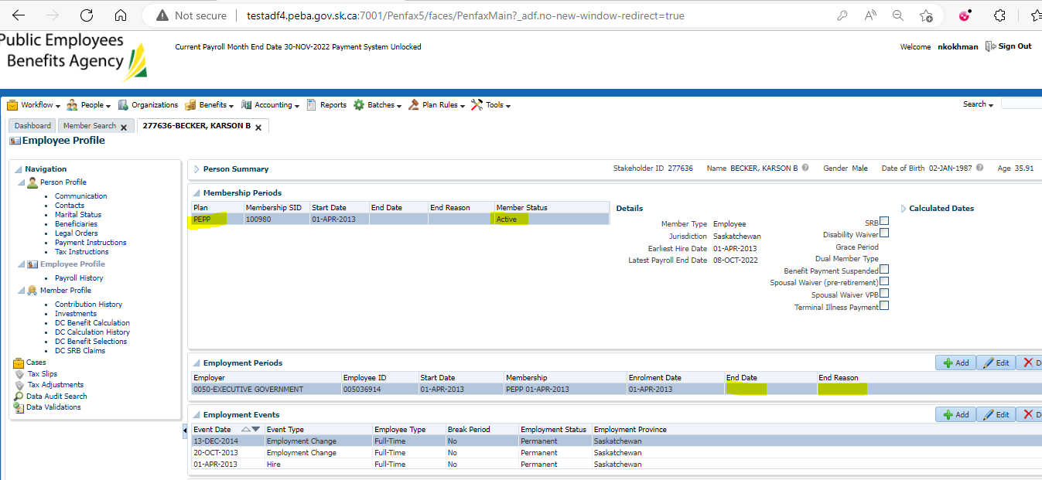

1. Log into DCT. Select an Employer from the dropdown and click on Import Data. Process a CSV file for Termination and then for Enrolment having same effective date as termination.

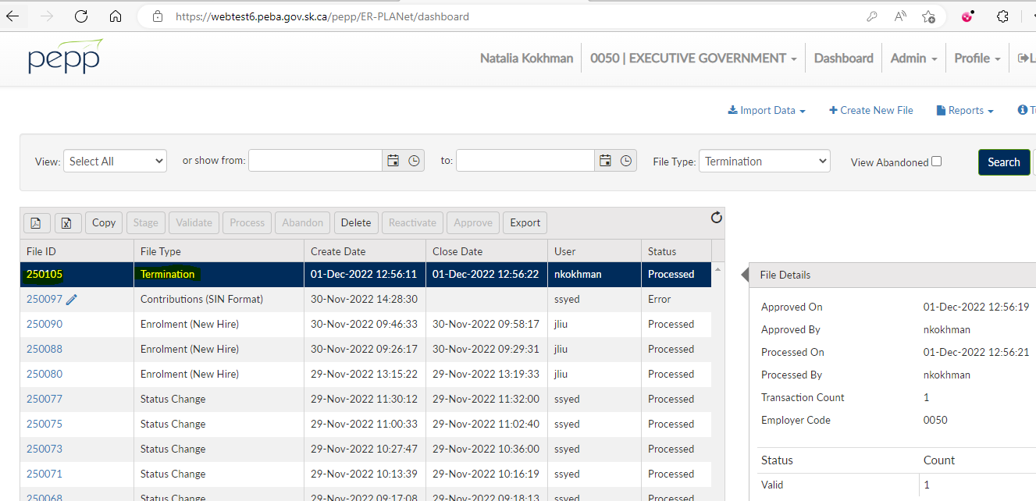

1. Go to Penfax and then Data Posting Batches. Click on Data Posting Batch ID, go to Pending tab and validate and then submit the transaction records.

Termination data posting batch

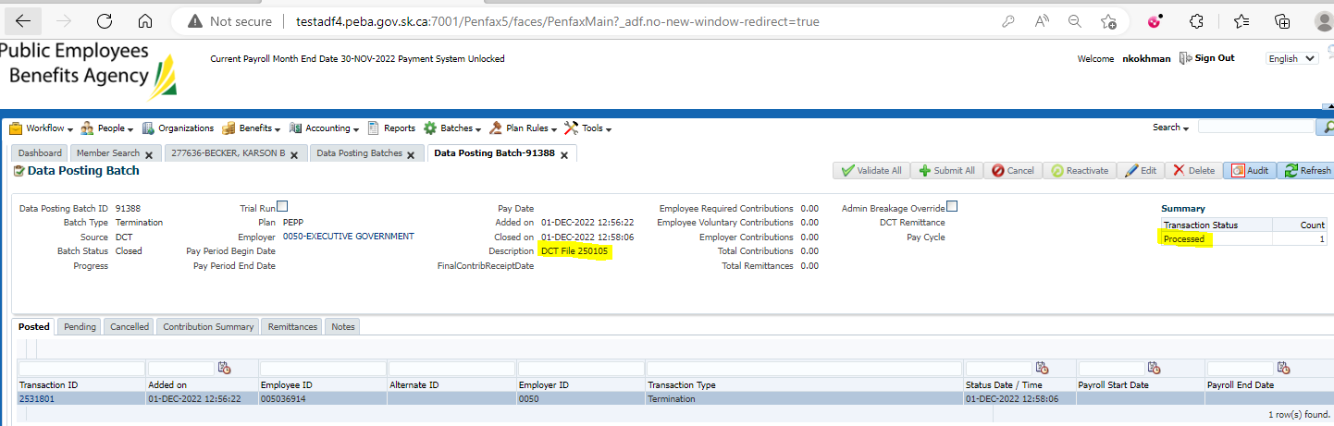

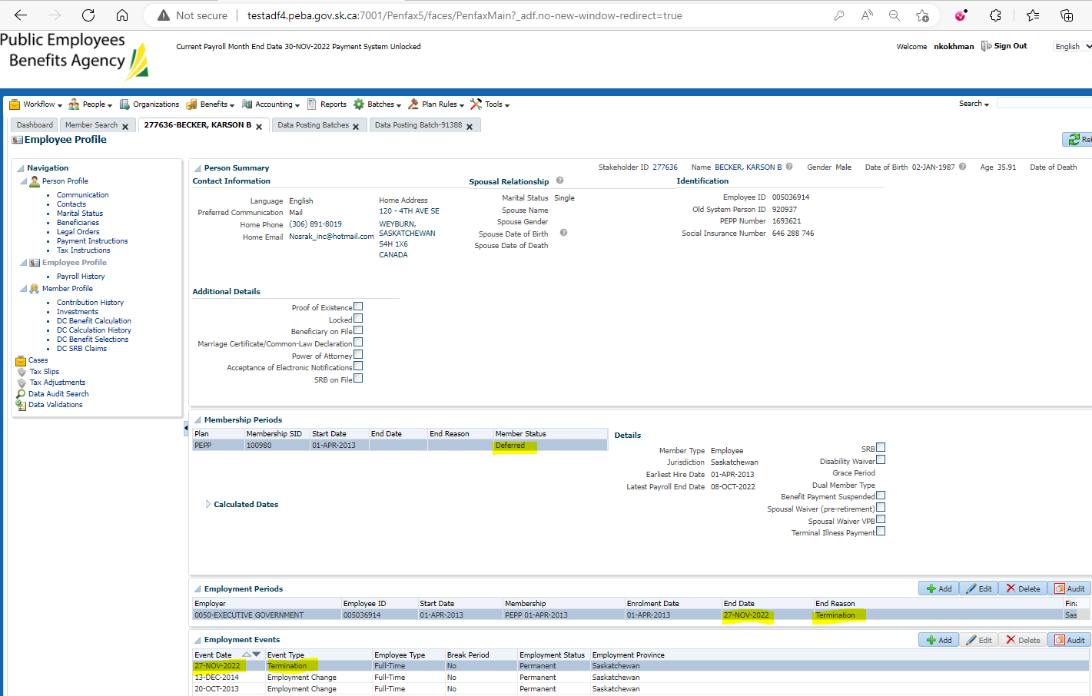

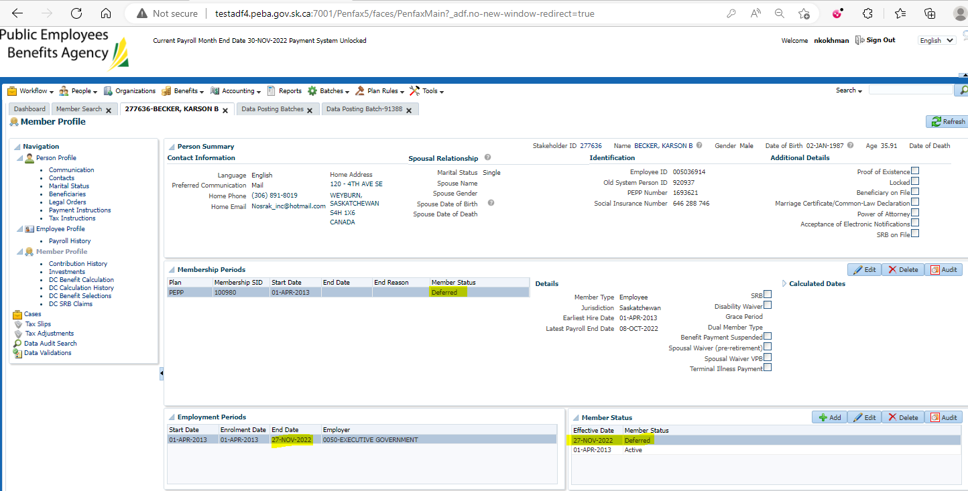

1. Enrollment DCT

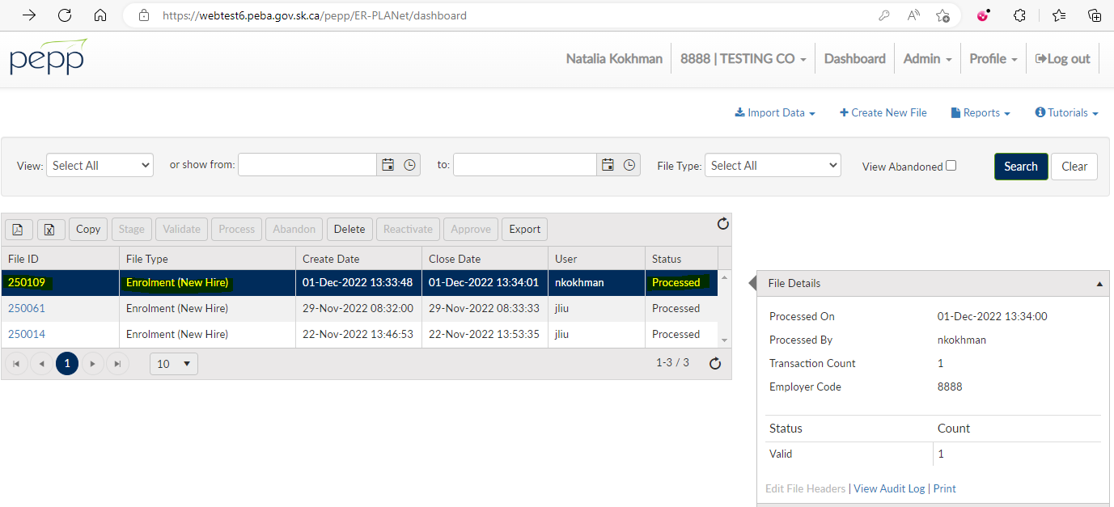

Enrolment data posting batch

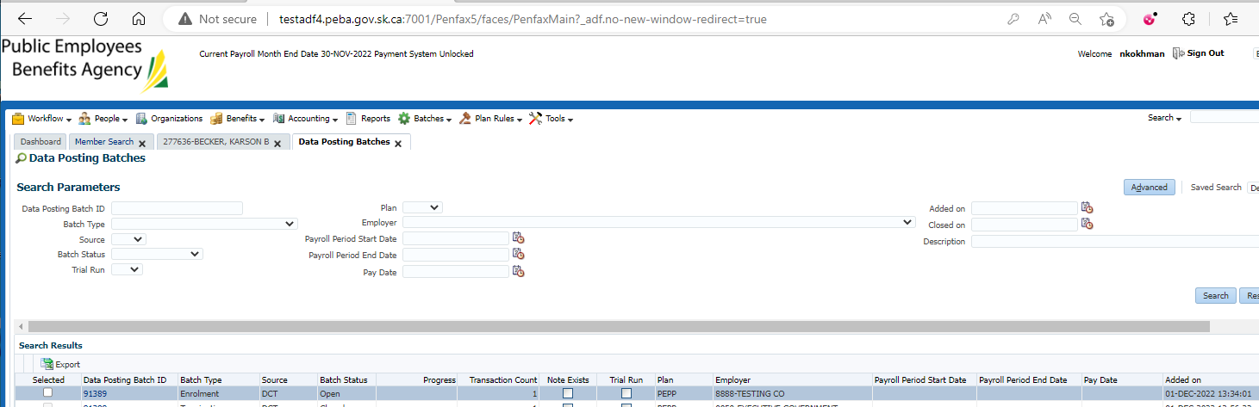

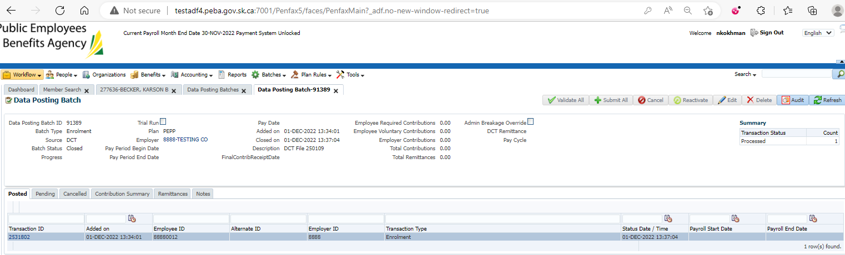

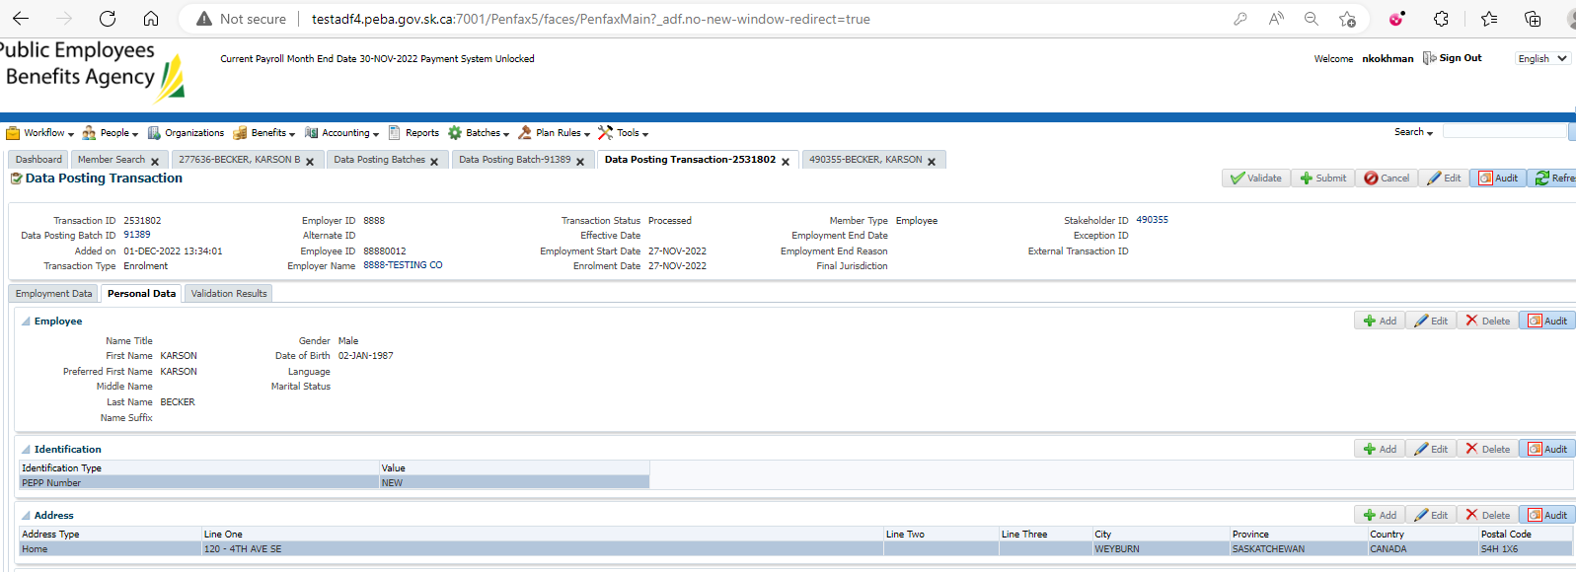

1. Once the data posting batch is submitted, bring up your member.
2. Go to Employee Profile -> Employment Periods, previous employment should now have the End Date and the Termination as the End Reason and the new employment record is available - No new employment created

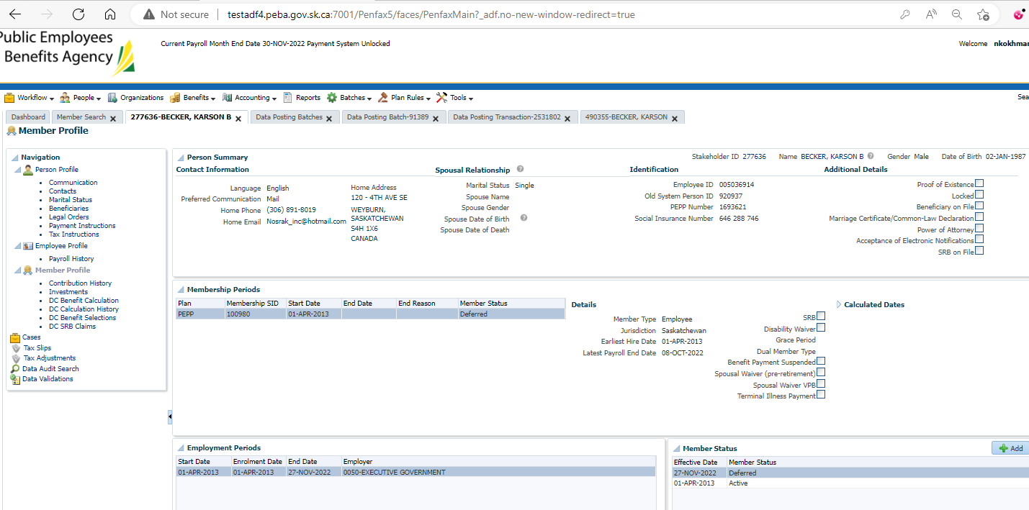

1. Go to Member Profile. Member Status should remain Active as termination and enrolment had the same effective date – Member status remained Deferred after the termination
2. Go to Person Profile -> Communication -> Outbound Documents -> Termination Option Letter should have been generated as termination was done before enrolment.
3. Letter PDF – Full letter saved in testing folder

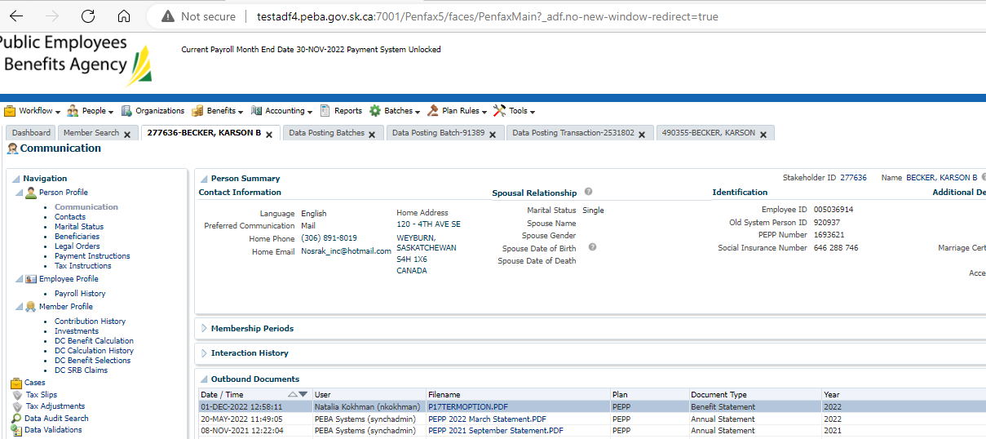

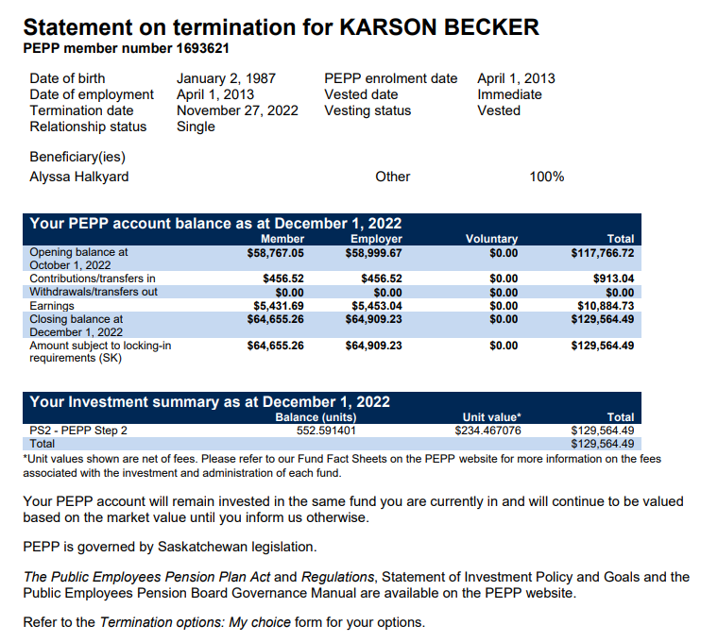

1. Termination Option Letter should be available in Member PLANet.

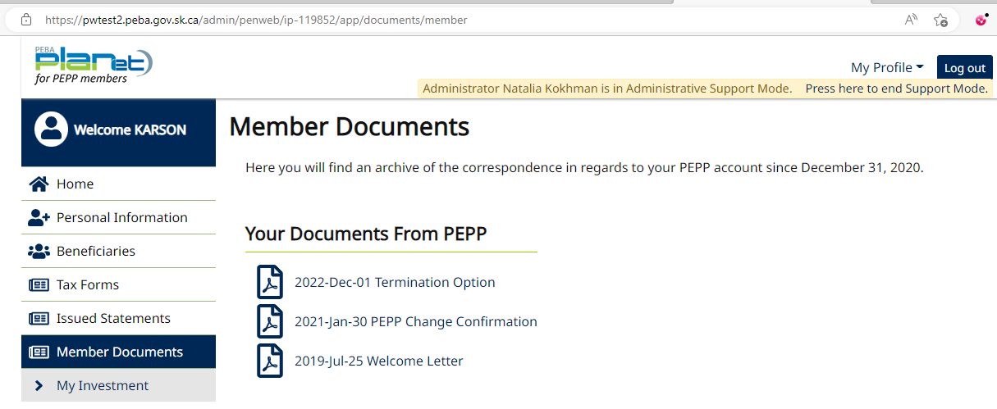

1. New stakeholder created – instead of adding a new employment record to the existing stakeholder

